Assignment – I (28.12.2021)

1) Create new queries to connect to the **(AdventureWorks_Product_Categories)**

and **(AdventureWorks_Product_Subcategories)** files from the course resources:

• Name your queries (AW_Product_Category_Lookup) and (AW_Product_Subcategory_Lookup)

• Confirm that headers have been promoted and that detected data types are correct

• Disable the report refresh option for both connections

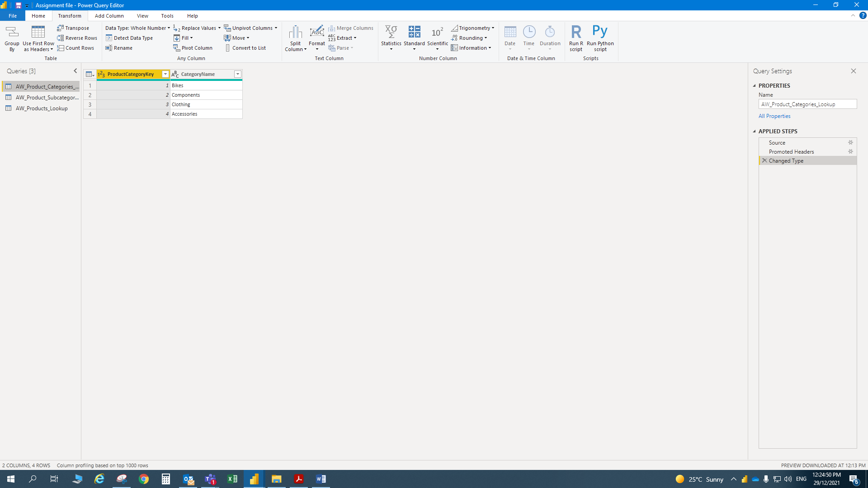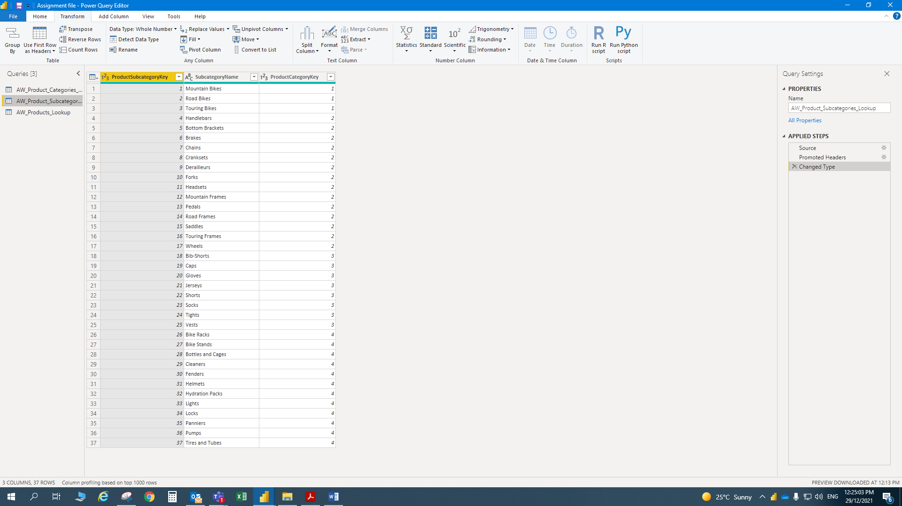

**2)** Make the following modifications to the **AW_Product_Lookup** query:

• Add a calculated column that extracts all characters before the dash ("-") in the **ProductSKU** column, named "**SKUType**"

• Update the **SKUType** calculation above to return all characters before second dash, instead of the first

• Replace zeros (0) in the **ProductStyle** column with "NA"

• Update the **DiscountPrice** calculation to 15%, by multiplying the **ProductPrice** values by 0.85 (instead of 0.9)

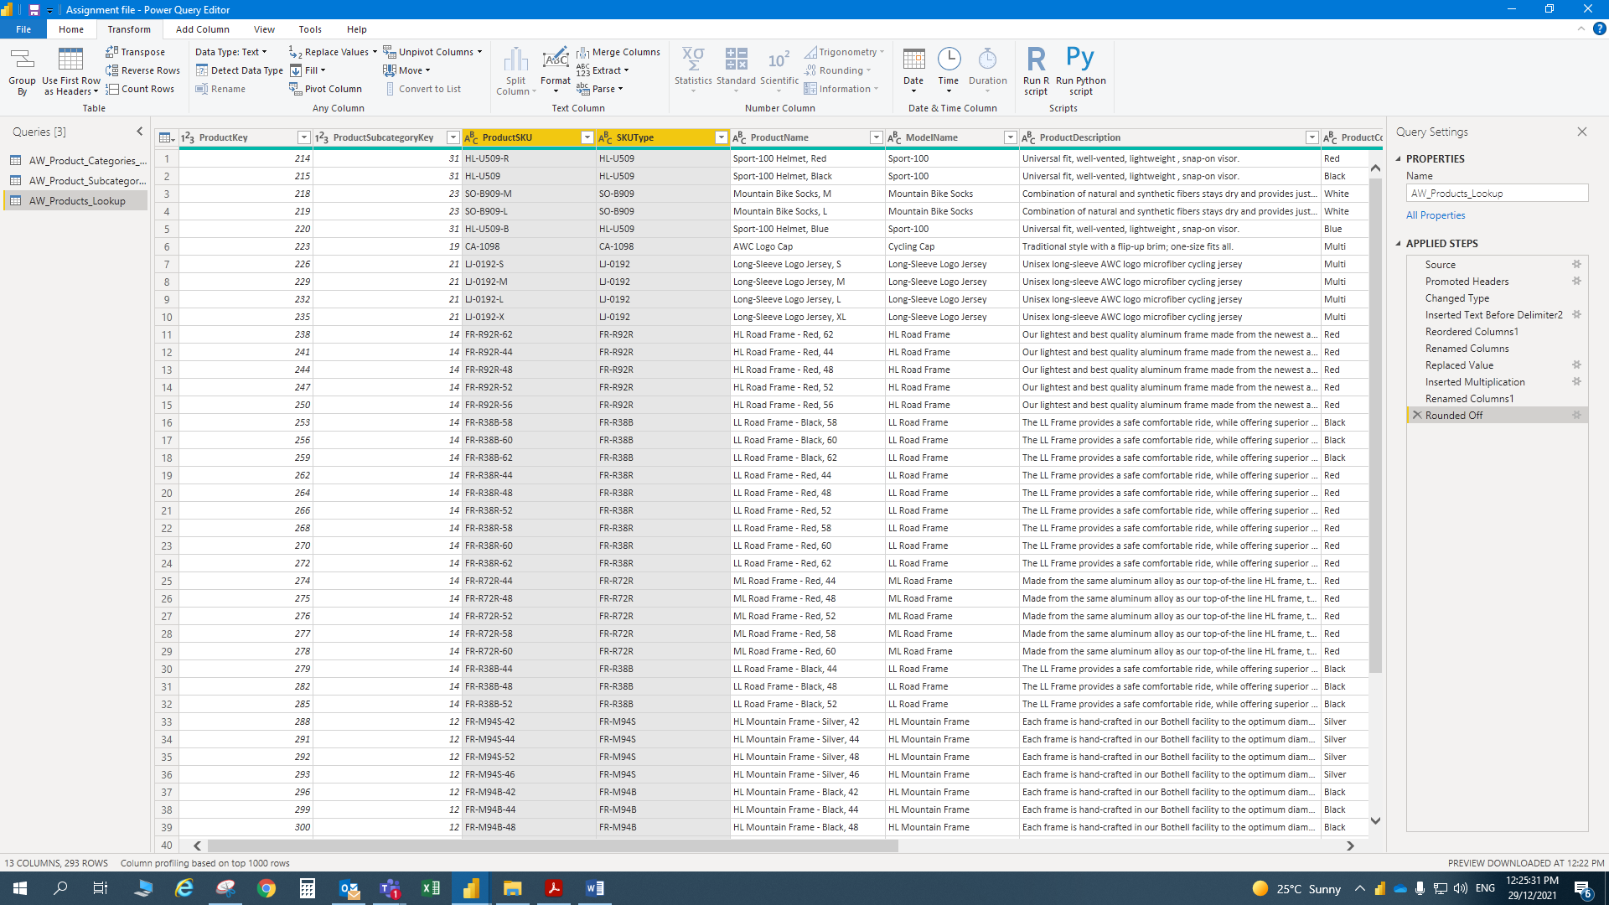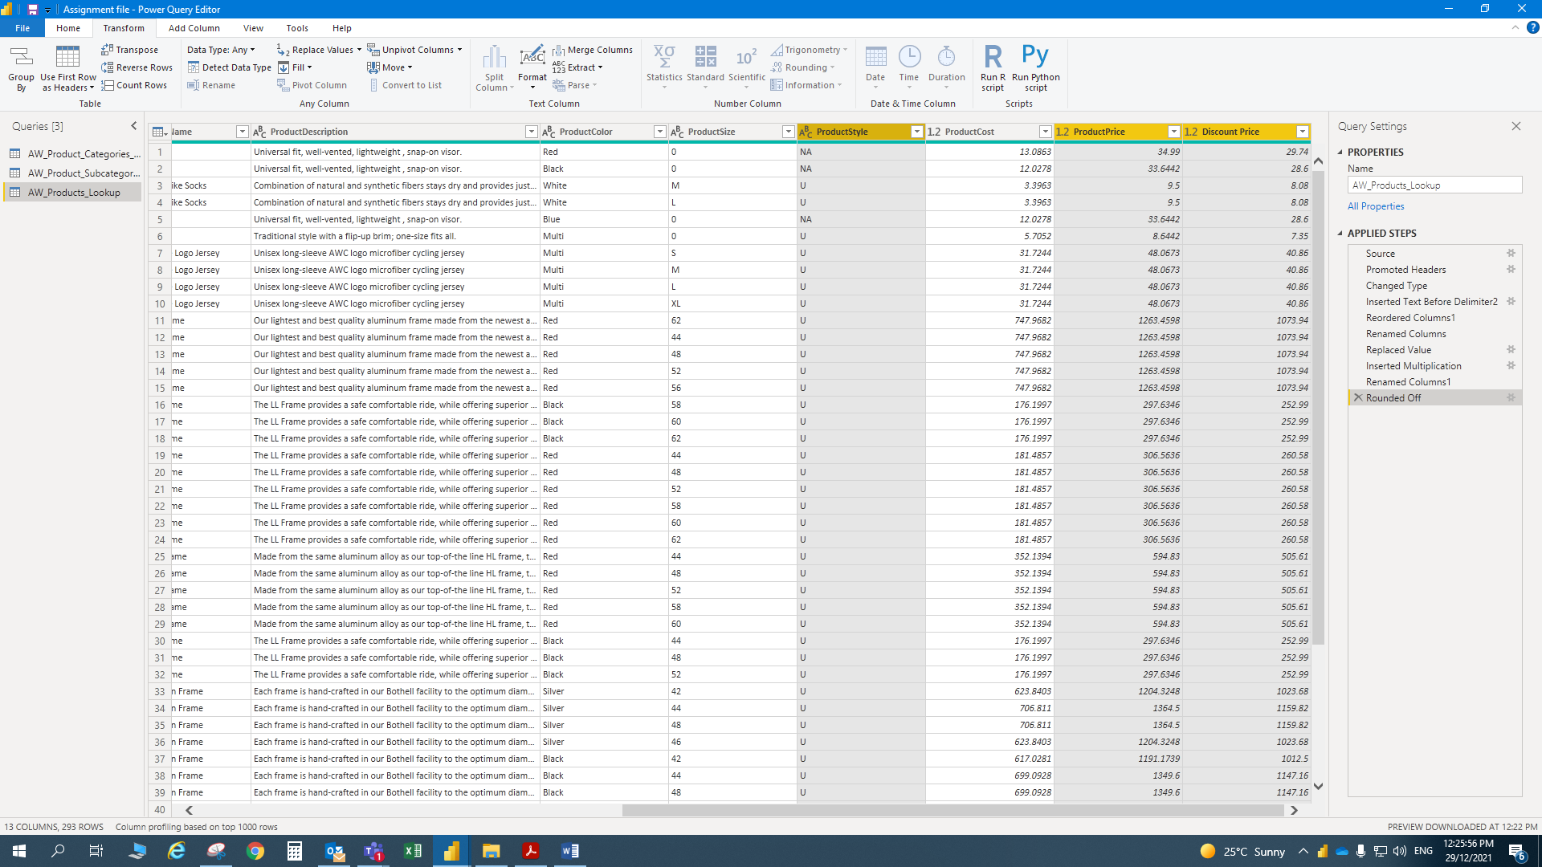

**3)** Using the Statistics tools in the Query Editor, confirm the following values :

• Average product cost (**$413.66**)

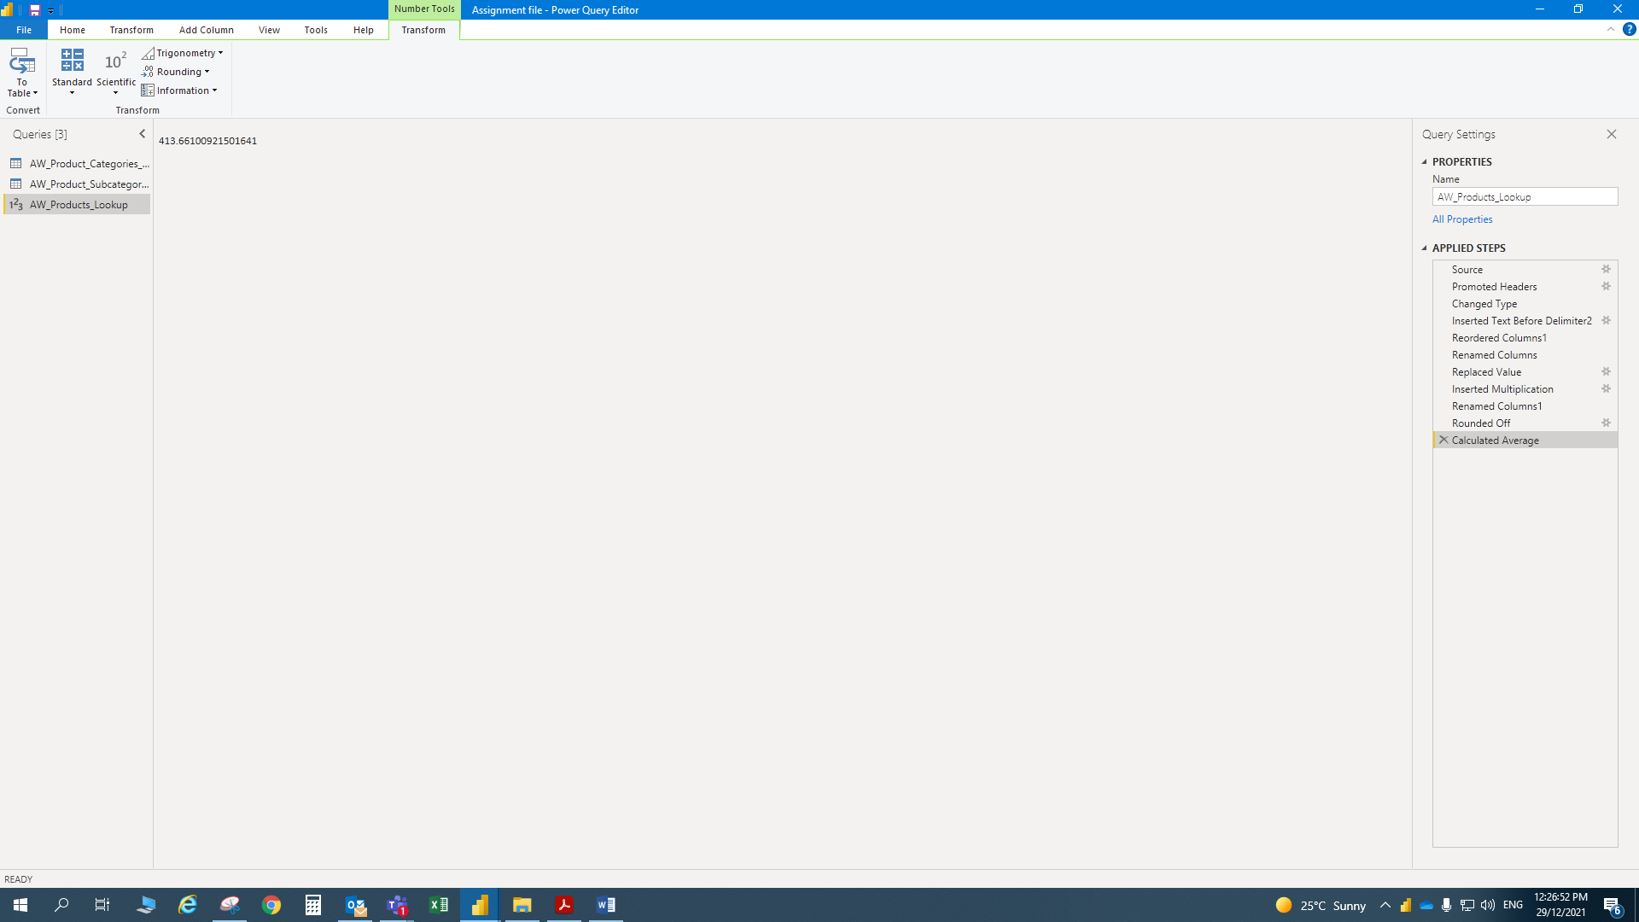

• Number of distinct product colors (**10**)

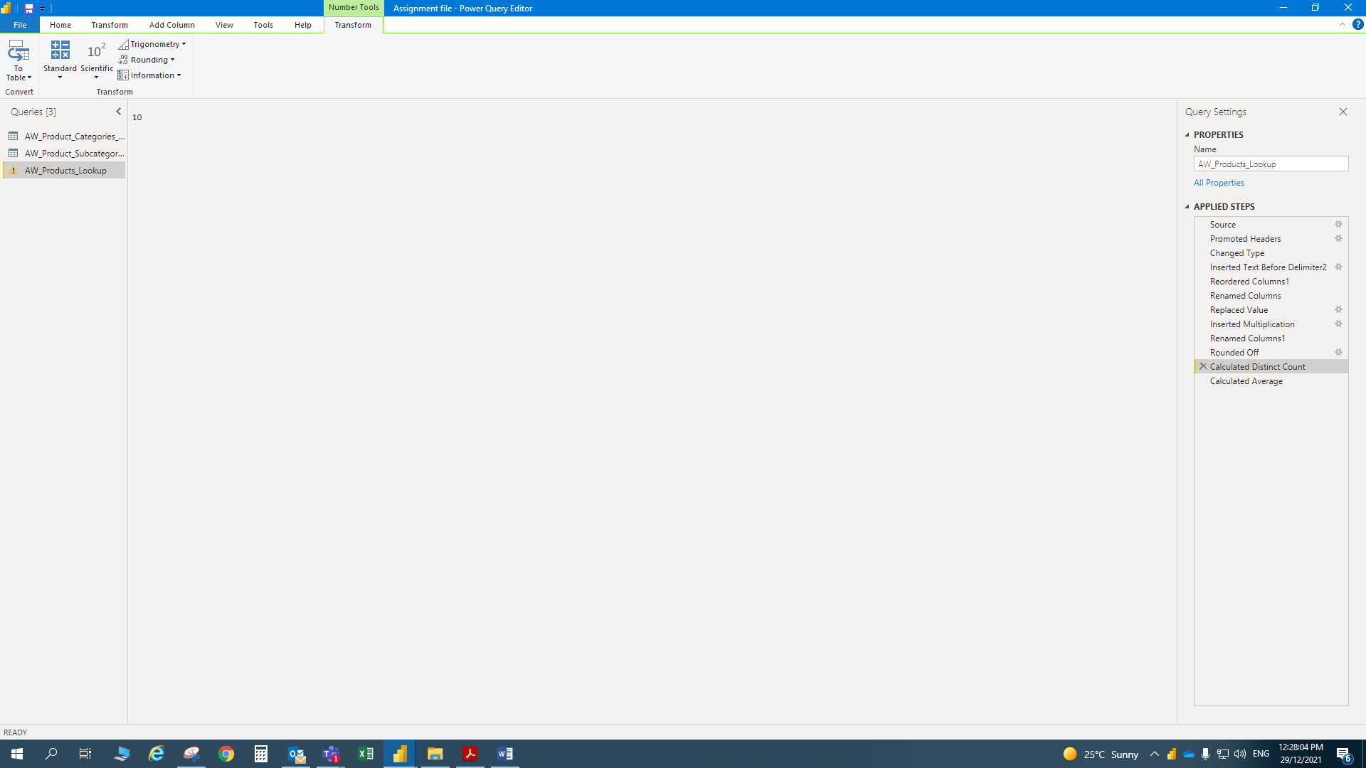

• Number of distinct customer names (**18,110**)

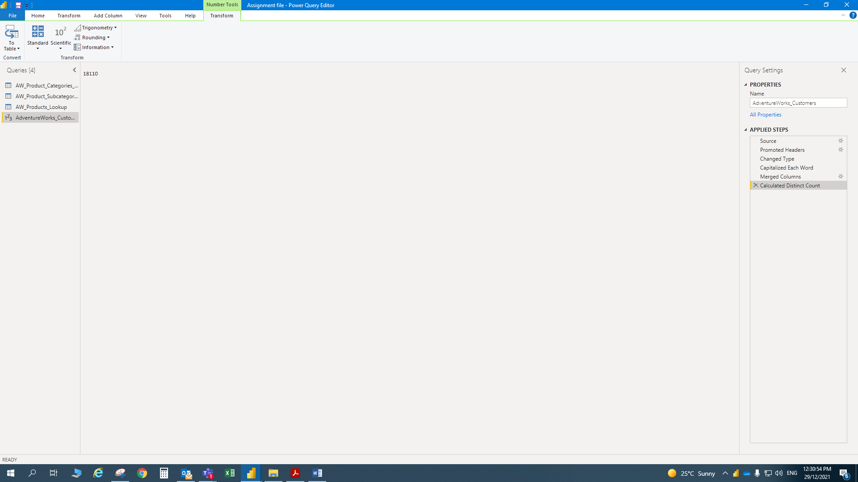

• Maximum annual customer income (**$170,000**)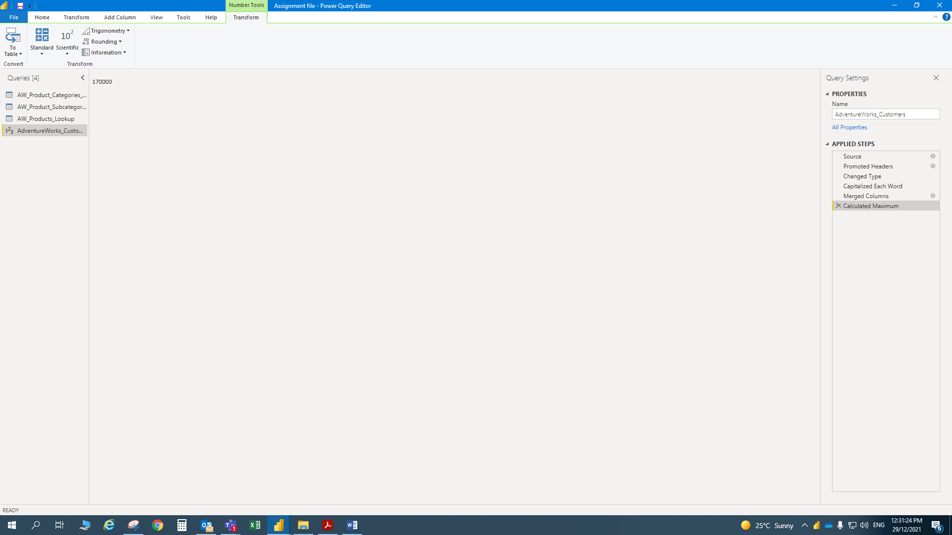

• Count of order numbers (**56,046**)

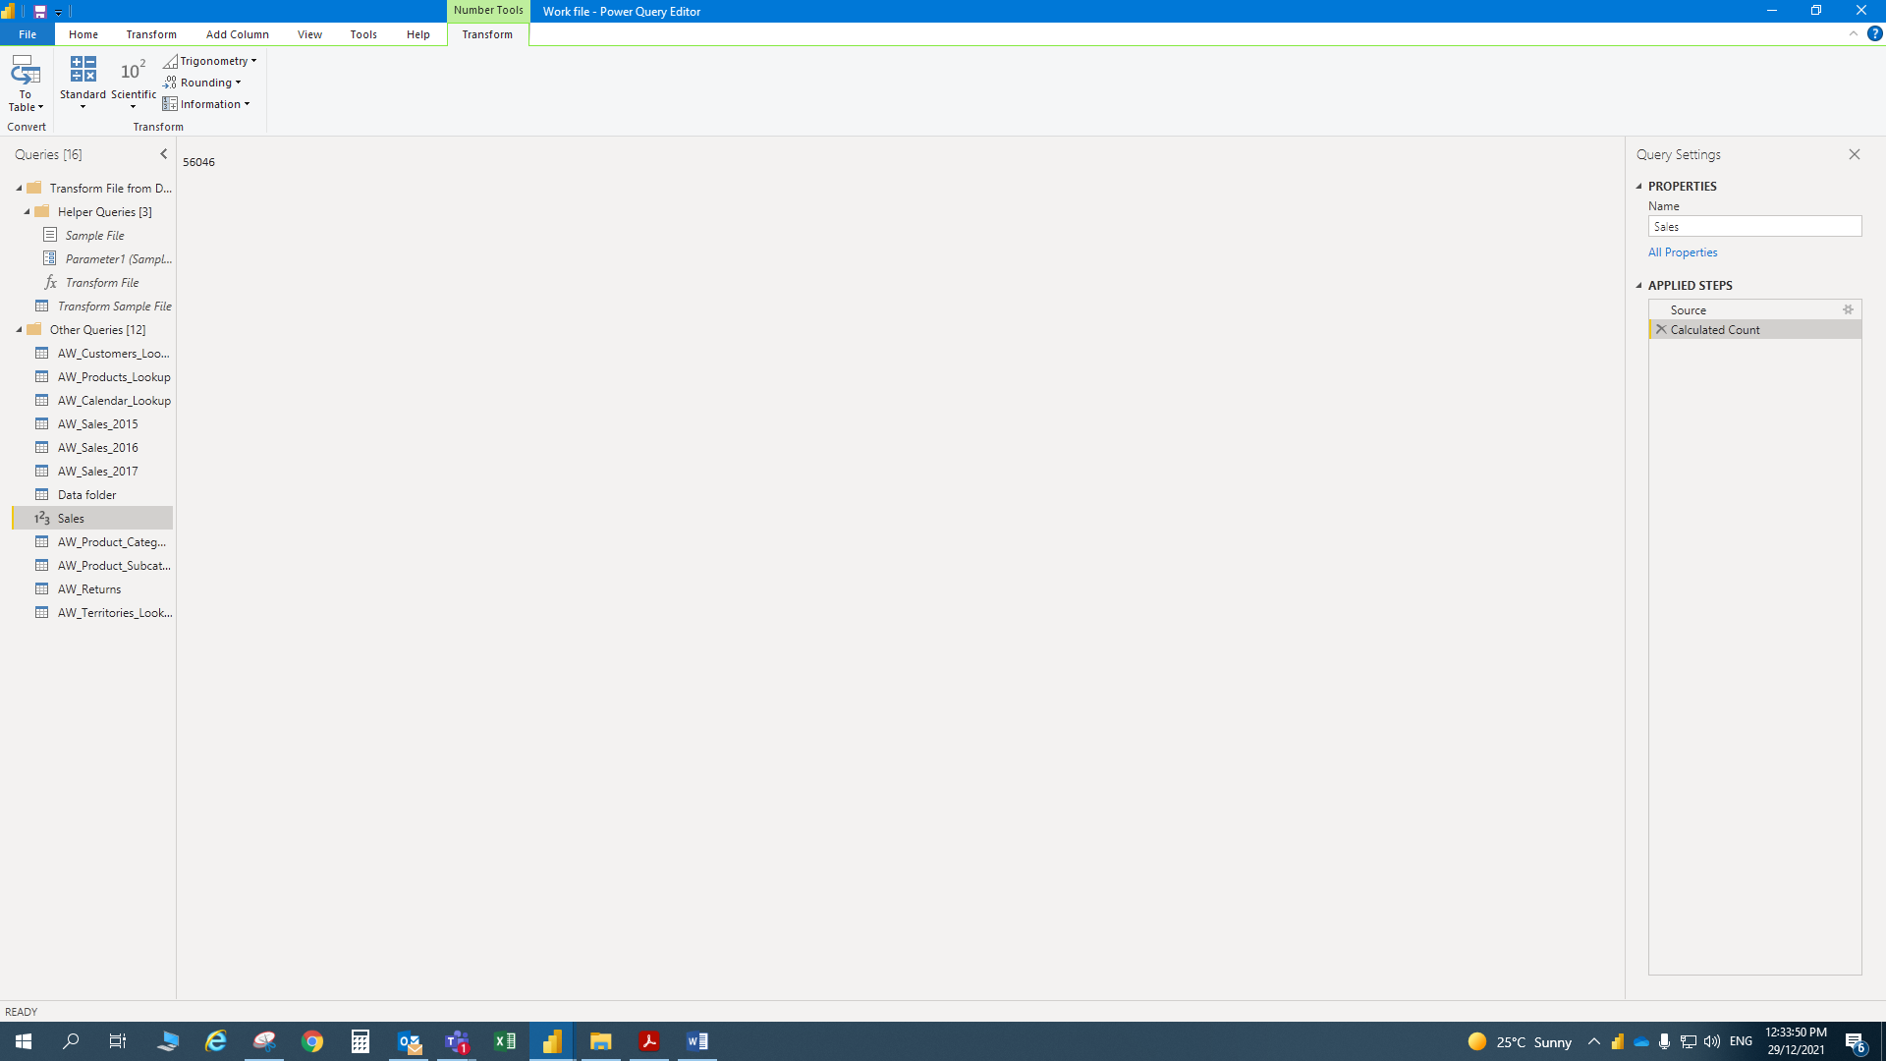

• Count of distinct order numbers (**25,164**)

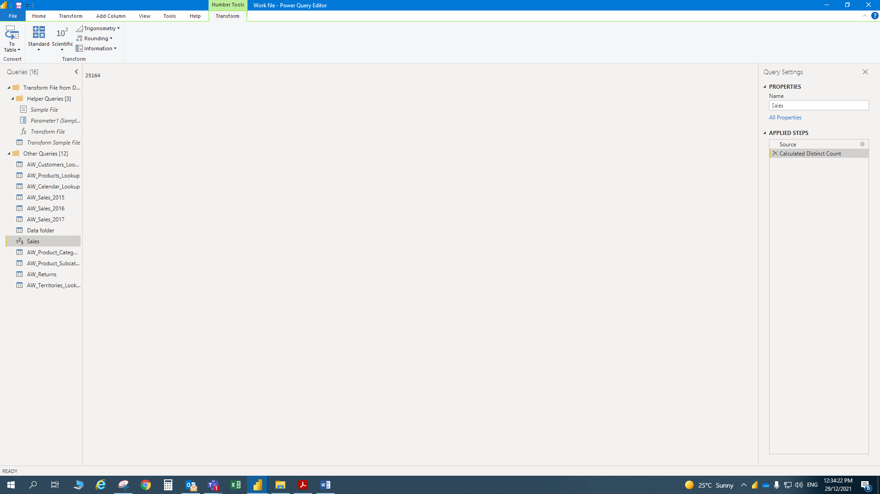

**4)** Make the following modifications to the **AW_Customer_Lookup** query:

• Add a new calculated column for the year of birth (named "**BirthYear**"), based

on **BirthDate**

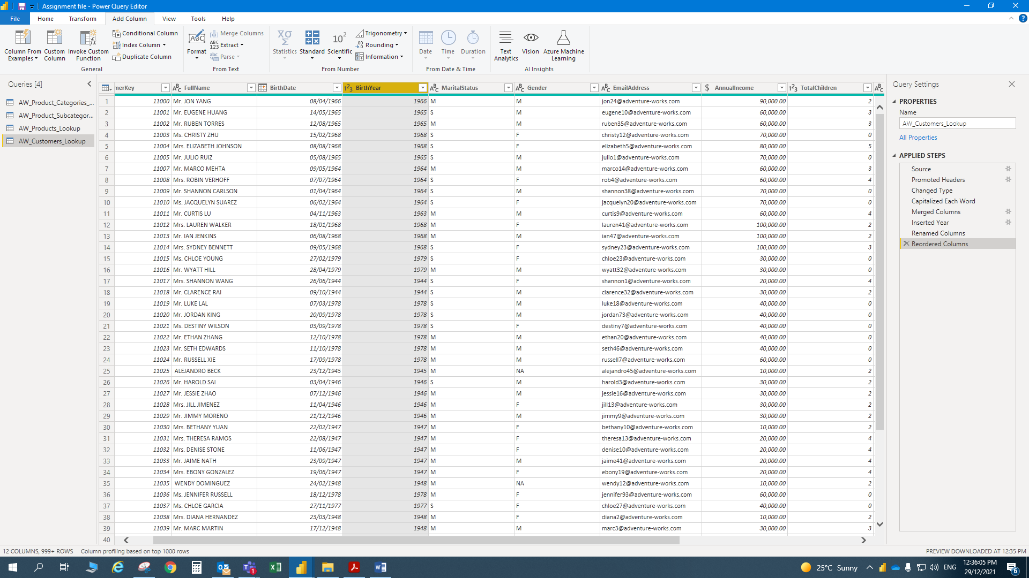

• Add a conditional column to categorize customer income (named

"**IncomeLevel**"), based on the following criteria *:*

• If **AnnualIncome** >= $150,000, then **IncomeLevel** = "*Very High*"

• If **AnnualIncome** >= $100,000, then **IncomeLevel** = "*High*"

• If **AnnualIncome** >= $50,000, then **IncomeLevel** = "*Average*"

• Otherwise **IncomeLevel** = "*Low*"

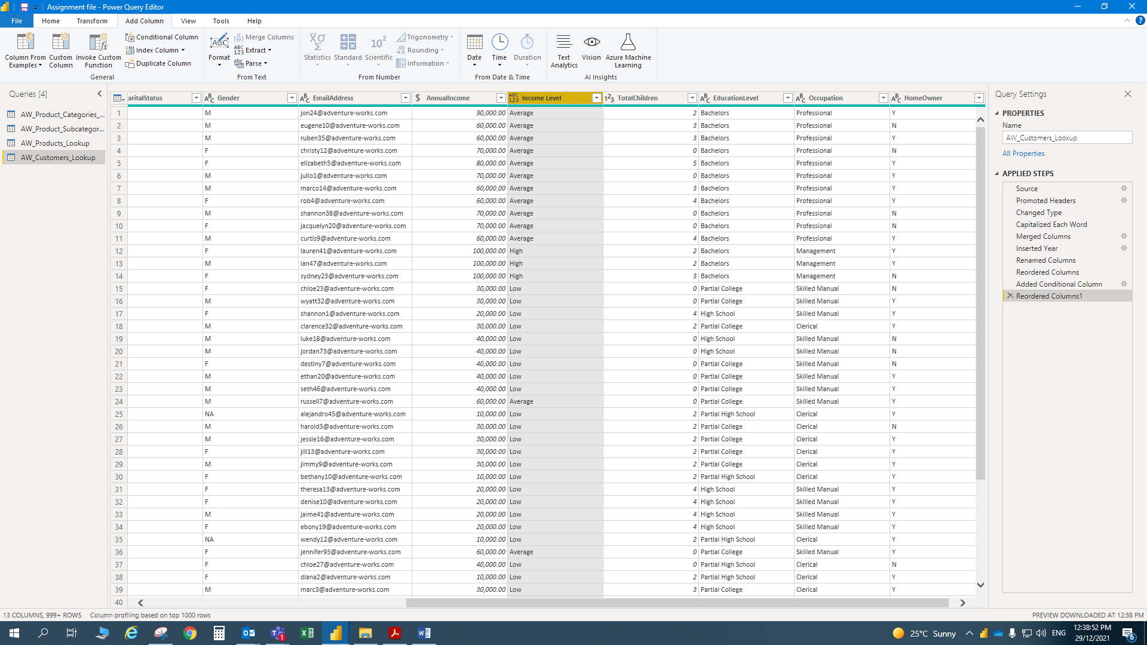

**5)** Apply all changes, and confirm that new tables and fields are accessible

within both the **Data** and **Relationships** views (recommend saving a backup copy of

the report (i.e. *"AdventureWorks_Report_Backup"*))

